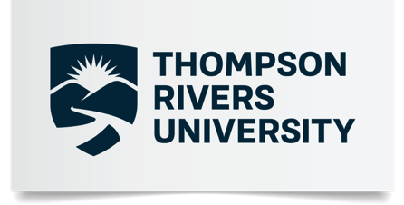

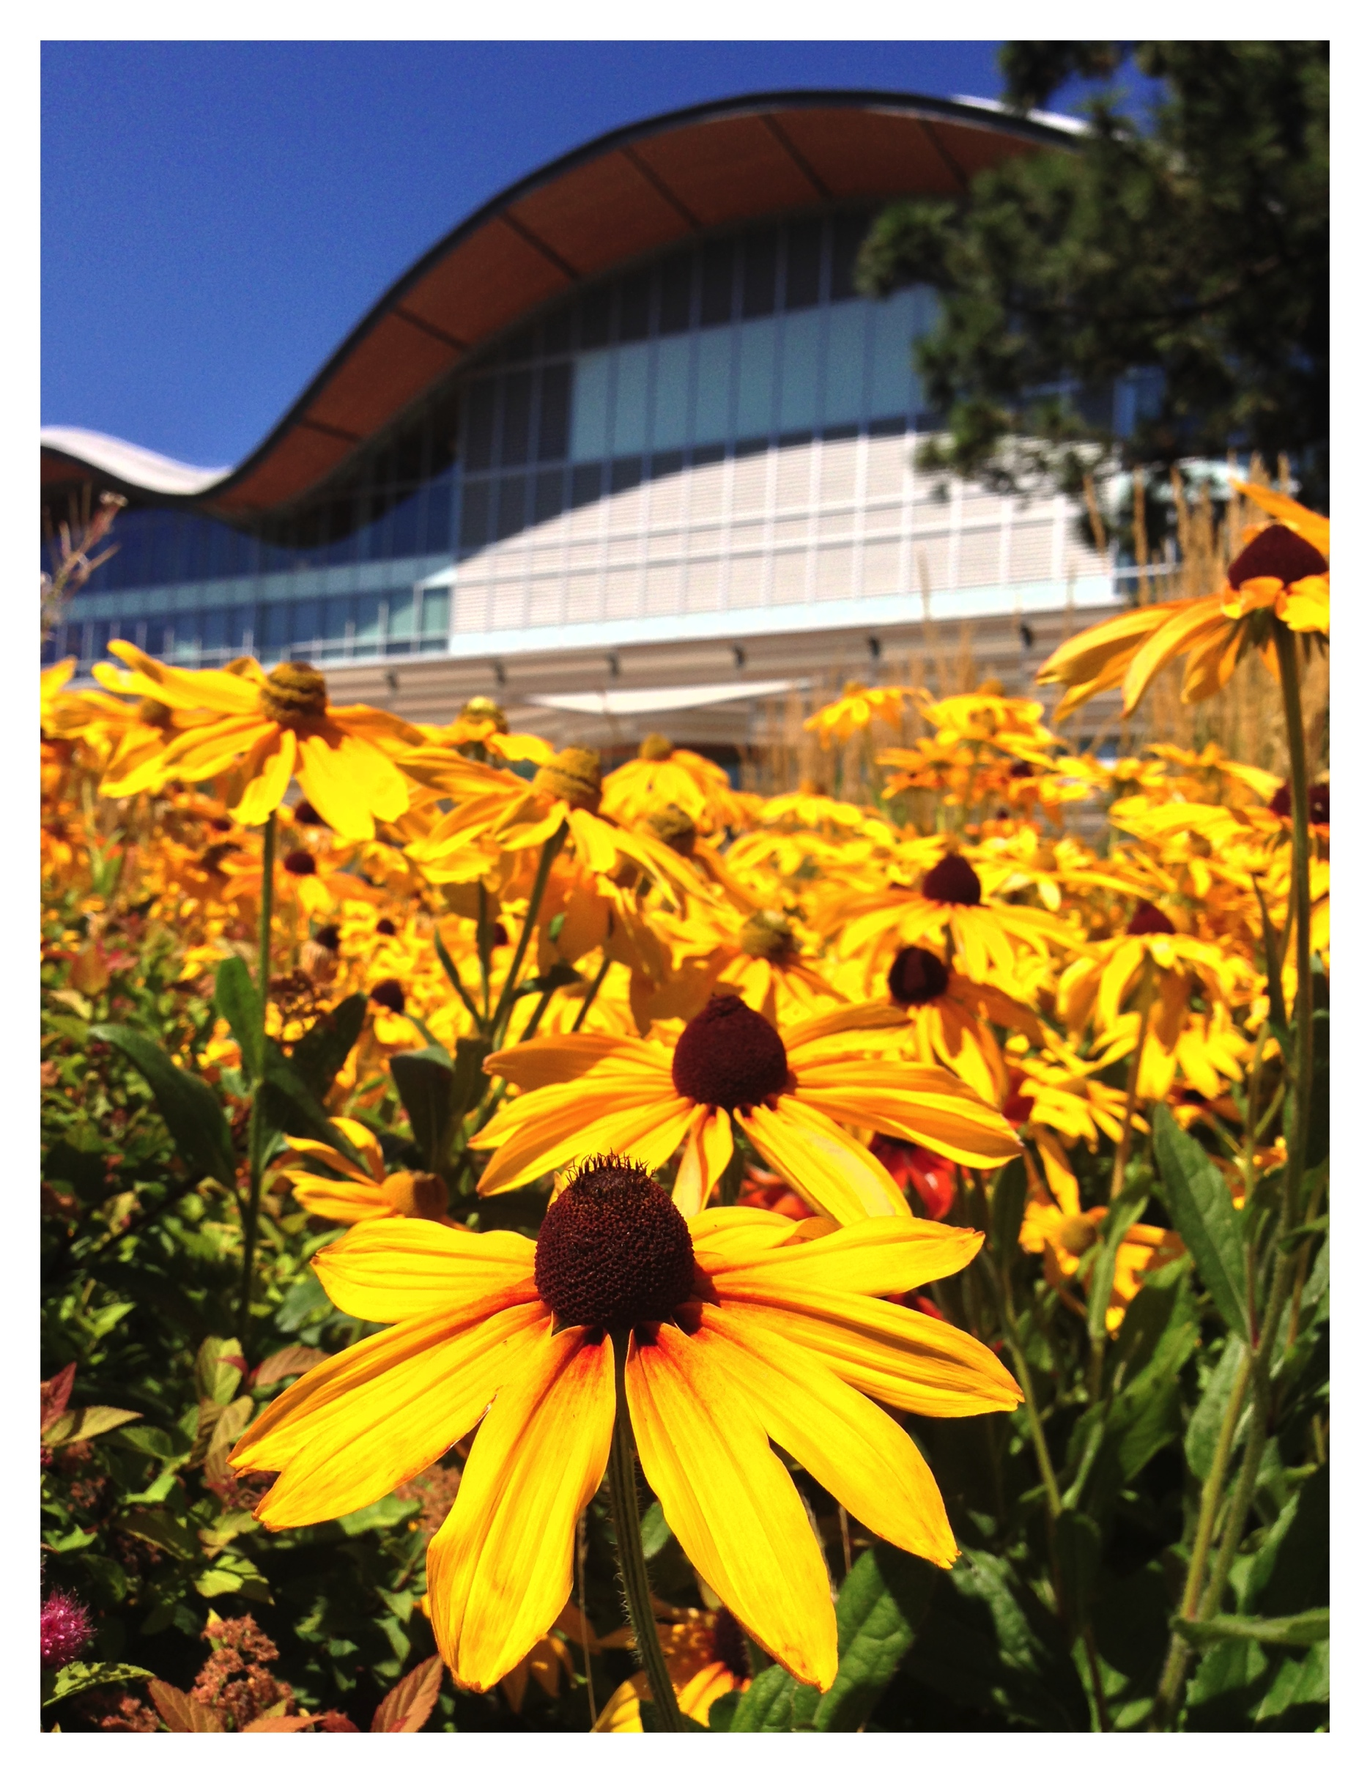
Understanding Asia Competency
At Thompson Rivers University

The Final Report of a Student-led Research Project
Conducted by Casey Helgason
With the support of Dr. Robert Hanlon, Thompson Rivers University and The Asia Pacific Foundation of Canada

Political Science | FACULTY OF ARTS

Summary

Canadians are living in what some writers have referred to as the Asian Century. Once perceived as a region defined by ideological conflict and economic risk, Asia has become critically important for sluggish Western economies looking to boost trade and fiscal growth.

As the Asian Development Bank suggests, the region is expected to contribute over 60 percent of global market expansion with most of this growth originating within Asia’s emerging economies. Governments that fail to recognize the significance of Asia’s rise nor develop strong policy on how to engage the region are at serious risk for becoming uncompetitive in this shifting global economic environment.

Students at Thompson Rivers University (TRU) in British Colombia recognize this changing economic landscape and set out to understand how the institution is preparing its graduates to help them navigate a diversified global economy driven by Asian growth. A student-led task-force was then established to survey undergraduates on TRU’s Kamloops campus.

The team spent four weeks conducting empirical research, performing unstructured and informal interviews with TRU students in the Faculty of Arts, as well as designing and administering a questionnaire to 101 student participants in the hopes of gaining a deeper understanding of student perceptions towards the region and educational resources available on campus for learners looking to enhance their familiarity with Asia.

Three significant findings can be drawn from this study that will be of interest to educators, university administrators and public policy planners:

- First, while respondents noted a serious interest in learning about Asia, few resources including university courses or seminars are available to introduce students to the dynamics of the region.

- Second, most respondents believe that Asia is significantly more important to the Lower Mainland when compared to the interior of British Columbia, pointing to a serious gap in understanding Asia’s economic impact and influence on the entire province.

- Finally, there is a motivational gap between the university’s institutional interests for recruiting students from Asia compared to TRU student incentive for participate in an academic exchange in the region.

These findings only provide a brief snapshot of what we see as basic yet structural challenges for achieving ‘Asia Competency’ on TRU’s campus. The hope is that this student-led study will serve as a catalyst for a more meaningful conversation on how to develop an institutional strategy for building student capacity in the new global economic environment. If British Columbia is to stay competitive and relevant, educators must find new ways for ensuring that the next generation of policy leaders are prepared to adapt and operate in an Asian Century.

Robert Hanlon, PhD
Assistant Professor of Politics
Thompson Rivers University
Kamloops, B.C., Canada

Introduction

This project developed out of a joint collaboration between Thompson Rivers University and the Asia Pacific Foundation (APF) of Canada. Through the support of the APF’s Asia Connect Student Working Group Program, the TRU Political Science Club, led by principle investigator Casey Helgason, designed a research project to gain an understanding of how students on campus perceive Asia. The findings of this study are to be presented (in Vancouver) at the APF Asia Connect Showcase.

The purpose of this study then, was to evaluate student perceptions of Canada-Asia relations at Thompson Rivers University. A 2016 study published by the APF states that 52 percent of residents in British Columbia felt a strong attachment to the Asia Pacific.

However, given the high concentration of British Columbia’s coastal population, as well as the variance in demographic makeup, the study does not offer a clear distinction between individuals living in the Lower Mainland and those who reside in the province's interior. Moreover, it does not capture the sentiments of young people who live in these areas.

This study therefore aims to shed light on this possible gap in perception based on geographical location while tapping into student opinions towards Canada-Asia relations. This project is built on the hypothesis that perceptions in the Lower Mainland of B.C. are overrepresented in the APF study while failing to accurately identify how cities in the interior of the province understand Canada-Asia relations. Moreover, it is unclear how young people in the province see this relationship.

Background

Kamloops and Thompson Rivers University

Kamloops is currently home to over ninety thousand residents and services roughly one hundred and thirty-seven thousand individuals. It is located in central British Columbia, its closest port being Vancouver. Thompson Rivers University is one of Canada’s newest and most comprehensive universities, offering a wide range of program options. Over twenty-five thousand students, both domestic and international, are enrolled in undergraduate and graduate university degrees, career diplomas, certificates, and trades training. According to statistics released by TRU’s Integrated Planning and Effectiveness Department, nearly 20 percent of the school’s On Campus population are International students. Of these students, 35 percent are from the Asia Pacific (roughly, 750 or 5 percent of the total On Campus population). Furthermore, in 2016, 472 or roughly 3 percent of the total On Campus population came from India. Asia, as a whole, contributes over 60 percent of TRU’s international student population.

Methodology

This study’s research method involved: 1. Utilizing pre-existing literature and research to illuminate the factors that lead to the varying perceptions of British Columbians when thinking about the Asia Pacific. Asia is currently home to nearly sixty percent of the world’s population and has become an economic and military frontrunner in global politics. Consequently, learning about Asian values and practices is of undeniable significance—if not simply to develop competency and understanding about the majority of the world. Furthermore, strong and amicable relations with Asia present great economic opportunity for Canada. The study also indirectly aimed to determine whether some findings published by the APF in its 2016/2017 National Opinion Surveys were relevant for interior students in B.C. 2. Developing and conducting a survey of a cross-section of: First, Second, Third and Fourth year students at TRU embodying our diverse demographic. We employed a five-point Likert Scaling model. (Appendix A) 3. Finally, gathering anecdotal opinion through unstructured informal interviews. This process provided truly candid content to the study.

The Survey

We chose to construct a survey to first, determine whether students at TRU feel a strong attachment to the Asia Pacific. Second, to elucidate whether there is a disconnect between TRU student’s perceptions and those of British Columbia as a whole. Finally, to determine whether there is a demand for more courses, information or access to experts at TRU. The survey (Appendix A) received ethical approval from TRU’s Office of Research and Graduate studies, which allowed us to officially begin the process.

We gathered information using a series of five-point Likert questions asking respondents to rate their level of agreement for fifteen Asia-related questions. We surveyed 101 Thompson Rivers University students who were asked if they would be willing to participate in a study exploring the perceptions of TRU students towards Asia. The two-page survey was filled out exclusively at Thompson Rivers University, administered randomly and took students approximately three minutes to complete.

The data elicited by this study is meant to provide a ‘snapshot’ of perceptions at TRU. While admittedly, findings are neither definitive nor representative, they serve the important purpose of illustrating a need and opportunity for more comprehensive exploration of the topic at TRU.

Findings

1.Canada and Asia’s economic ties are of significant importance.

We found responses to this question to be overwhelmingly positive with 87 percent of participants stating they either agreed or strongly agreed. 4 percent answered neutrally while the remaining 9 percent reported that they did not agree that Canada and Asia’s economic ties were of significance. The recent 2017 National Opinion Poll published by the APF supports these findings, particularly sections on the benefits of strengthened economic engagement with China.

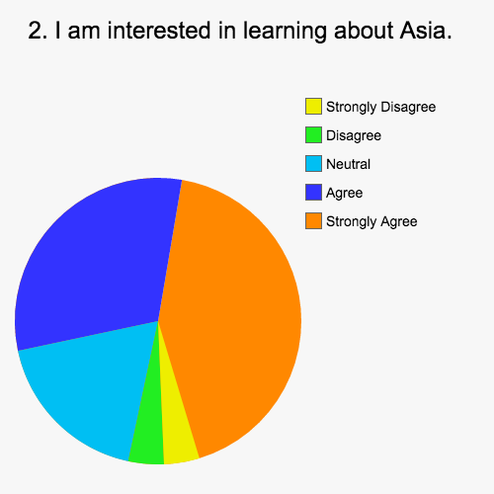
2. I am interested in learning about Asia.

Our study demonstrated that the majority of participants were interested in learning more about Asia. 74 percent responded positively. 18 percent answered neutrally and a small minority, 8 percent, said they had no interest. Informal and unstructured interviews suggest that there is a lack of access at TRU despite demand. While TRU has recently implemented a global competency certificate, there seems to be a motivational gap in regards to Asia. When we inquired with TRU Abroad as to how many domestic students annually made academic related trips to Asia (Study Abroad, Conferences, Competitions etc.) the response received was “too few to document.”

3. I have covered Asian history in one or more of my classes at TRU.

Responses to this question indicate that the majority of students surveyed had not covered Asian history in one or more of their classes at TRU. 57 percent answered that they disagreed or strongly disagreed with the statement. 12 percent answered neutrally. The remaining 31 percent asserted that they had been exposed to Asian history during their education at TRU. These findings were not surprising given the lack of Asia themed courses at the university. However, it did strike us as troubling that students could complete a post-secondary degree without encountering the diverse histories of over half of the world’s population.

4. I actively seek out information about Asia.

Responses to this question were mixed. 27 percent of participants said they did not actively seek out information about Asia. 32 percent answered neutrally. The remainder of our cohort, 41 percent, provided a positive response. This mixed response may be in part credited to lack of programming that requires students to seek out information about Asia.

5. I would take an elective to learn more about Asia.

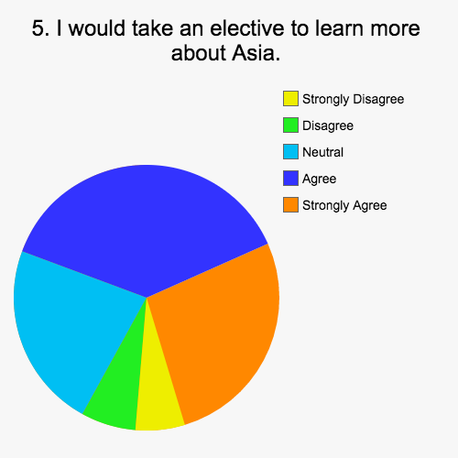
Findings from our study demonstrate that the majority of our sample would take an elective to learn more about Asia. 67 percent of students responded positively. 22 percent responded neutrally. The remaining 11 percent of participants answered negatively. Answers here reconcile with responses from question two and demonstrate further need at TRU for more education opportunities. Several students expressed a desire to learn Mandarin, while others were interested in religion, etiquette and traditional practices in Asia.

6. I talk about Asia with my Friends.

57 percent of our cohort responded positively to this statement. 57 percent asserted they agreed that they talk about Asia with friends. 9 percent answered neutrally. 34 percent answered negatively. Again, these findings demonstrate that students at TRU are discussing Asia. More resources and opportunities to access information about the region would likely help to increase positive responses.

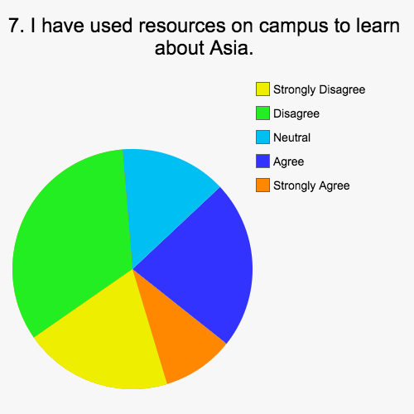
7. I have used resources on campus to learn about Asia.

The majority of participants (53 percent) said that they disagreed or strongly disagreed that they had used resources on campus to learn about Asia. Given answers elicited in question three, this is unsurprising. 14 percent of respondents answered neutrally, while the remaining 33 percent provided positive answers.

8. I have positive feelings towards Asia.

65 percent of our cohort answered positively to the statement “I have positive feelings towards Asia”. 28 percent gave a neutral response. A much smaller 7 percent provided a negative response. This finding is conducive with the APF’s 2016 National Opinion Poll—during the informal interview portion of our research, students commented on their appreciation for TRU’s diversity and support for student exchanges. However, this appreciation did not translate when we looked at domestic student exchanges to Asia.

9. I do not generally understand Asian Culture.

Responses to this question were mixed. 31 percent of participants stated that they did generally understand Asian culture. 28 percent answered neutrally. 41 percent agreed or strongly agreed that they lacked understanding.

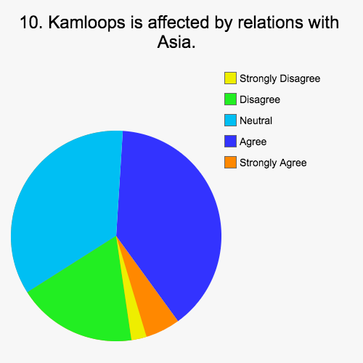
Results from this question, in culmination with findings elicited in previous questions (namely three and five), suggests that there is an opportunity for TRU to help foster greater understanding.

10. Kamloops is affected by relations with Asia.

This question administered a mixed response. 20 percent of participants disagreed or strongly disagreed that “Kamloops is affected by relations with Asia”. A surprising 35 percent answered neutrally. This neutral response could be a further representation of lack of understanding given the much less significant (8 percent) of respondents who answered neutrally to question eleven. The remaining 45 percent of our cohort said that they either agreed or strongly agreed with the statement. These findings, in culmination with findings in question eleven seem to suggest a major perceptual gap in understanding.

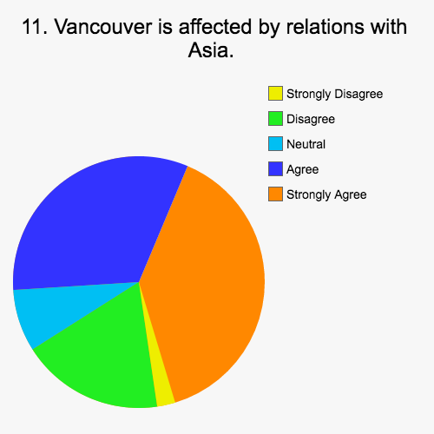
11. Vancouver is affected by relations with Asia.

This question was inserted as a control for question ten. The synthesis of findings from question ten and eleven support our hypothesis that individuals located in the interior of B.C. do not feel that they are as affected by relations with Asia as those located in coastal B.C. 73 percent of our respondents either agreed or strongly agreed that “Vancouver is affected by relations with Asia.” 8 percent answered neutrally. Only 19 percent disagreed of strongly disagreed with the statement.

12. I am interested in Asian politics.

This question elicited a mixed response. 34 percent of respondents disagreed or strongly disagreed with the statement “I am interested in learning about Asian politics.” 26 percent answered neutrally and the remaining 40 percent agreed or strongly agreed with the assertion. Given that previous findings indicate that the majority of participants are interested in learning more about Asia, it is likely the case that the introduction of ‘politics’ is to be credited for this variance.

13. I trust what I hear on the news about Asia.

47 percent of our respondents answered that they disagreed or strongly disagreed that they trust what they hear on the news about Asia. 32 percent provide a neutral response and 21 percent agreed or strongly agreed. If we consider the lack of respondents who actively seek out information about Asia (question 4) in light of these responses, it is likely participants lack a credited/reliable source to help form educated opinions, perpetuating conceptual gaps.

14. I have learned about cultures other than my own at TRU.

The majority of our participants (58 percent) either agreed or strongly agreed with the statement. 25 percent answered neutrally. The remaining minority (17 percent) disagreed or strongly disagreed that they had learned about cultures other than their own. If we consider question three, these findings may suggest that Asian culture is underrepresented in TRU course material. This point can be argued further given Asia’s significance at TRU using IPE statistics.
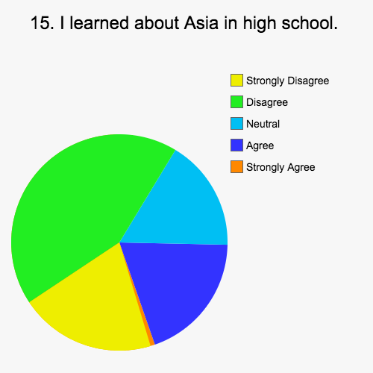
15. I learned about Asia in high school.

63 percent of respondents disagreed or strongly disagreed with the statement “I learned about Asia in high school”. 16 percent replied with a neutral position and the remaining 21 percent answered positively. These findings reconcile with findings from question three. It is quite possible that the two represent a systemic lack of representation in western education. Furthermore, the overwhelmingly positive response to question two suggests an opportunity and demand to address said need. TRU currently offers a Bachelor of Education program, which could benefit from the recent implementation of Asia-Pacific curriculum in B.C. However, without access to seminars and experts at the training level, one might ask how these prospective teachers will become qualified to teach Asian history and socials classes. There appears to be real opportunity to address this systemic underrepresentation at elementary and secondary levels by increasing access to experts and course content at TRU.

Discussion

The survey helped to solidify several themes that had emerged in our literature review and informal interviews. The first and most apparent of these themes was a lack of Asia related resources on campus. Despite interest and demand, there are few course or seminar options to facilitate Asia competency. Several students attested to only encountering one or two courses specific to Asia during the entirety of their undergrad in the Faculty of Arts Department—a trend that continues or worsens in the School of Business and Education Departments. This lack of access leaves students disadvantaged and unprepared for the ‘Asian Century’ and puts TRU at risk of being left behind on a global scale. Increased access to resources can ensure interior students develop and grow to succeed in this changing political and economic landscape. With more comprehensive Asia programming we can begin to mitigate misconceptions caused by perceptual gaps and bridge competency. We also detected an institutional motivation gap during our research. Thompson Rivers regards students from Asia as a major cornerstone of the university (recall, over 60 percent of international students are from Asia). Yet, this institutional interest in recruiting students from Asia does not translate into domestic student interest in visiting the continent. Furthermore, during informal interviews, discussion on ‘Asia’ was overwhelmingly dominated by China. This was somewhat troubling considering TRU’s IPE report states that 29 percent of our exchange students come from China and 22 percent from India. India was not mentioned representationally, which may be further credited to misconceptions regarding Asia. In fact, several students were surprised to discover India was a part of Asia demonstrating an undeniable need to expand Asian education.

Recommendations

- TRU to develop a task force to identify clear synergies between faculty, students and administrative regional interest
- More campus outreach and transparency to show how the university secures and tries to develop formal MOUs with institutions in Asia to help student exchange to the region
- More events, faculty, bursaries, etc. to support TRU-Asia related work
- Possible joint partnerships between interior universities to boost Asia competency
- Finding ways to build synergies between new BC high school curriculum that has an Asia Pacific Focus and universities
- Lobby provincial government to create an intergovernmental task force on how to promote BC university exchange to Asia. Government support for ensuring smaller institutions have clear strategies for engaging Asian universities
- More field schools to region.

Future Research Opportunities

- How can Canadian-Asia scholars collaborate sustainable development research
- Track-Two channel collaboration between faculty in Canada-Asia
- Identifying Exchange programs
- Language growth, synergies with high schools and motivational issues at university
- What is Asia? How do students understand the region in more depth?
- Linking geographical perceptual gaps— How can TRU help to foster representational discussion of India?
- Gap between incoming and outgoing – why TRU student demand to go to Asia is low. Why Canadian student demand to go to Asia is low?

Conclusions

In summation our research has aimed to provide a snapshot into TRU student perceptions towards the region and educational resources available on campus for learners seeking to enhance their familiarity with Asia. Admittedly, our findings are neither definitive nor representational but have identified that our student population wants to build Asian competency and there is a need for better access to said resources. We also affirm that there appears to be an institutional motivational gap. Based on our findings, we have posed recommendations with the ultimate goal of fostering stronger connections with Asia as a whole. With further research and funding we hope to bridge perceptual and motivational gaps, ultimately fostering more globally minded and prepared citizens.

Endnotes

2016 National Opinion Poll.” The Asia Pacific Foundation of Canada. August 2016. Accessed December 18, 2016. http://www.asiapacific.ca/surveys/national-opinion-polls/2016-national-opinion-poll-canadian-views-asia
“Factbook – Fiscal Year 2015-16.” Thompson Rivers University Institutional Planning & Analysis. August 2016. Accessed February 20, 2017.http://www.tru.ca/__shared/assets/factbook-2015-201638956.pdf
2016 National Opinion Poll.” The Asia Pacific Foundation of Canada. August 2016. Accessed December 18, 2016. http://www.asiapacific.ca/surveys/national-opinion-polls/2016-national-opinion-poll-canadian-views-asia Appendix: Appendix A Understanding Asia Competency at Thompson Rivers University Questionnaire Please circle the appropriate number for each statement, which corresponds most closely to your desired response. 1. Canada and Asia's economic ties are of significant importance. Strongly disagree Disagree Neutral Agree Strongly agree 1 2 3 4 5 2. I am interested in learning about Asia. Strongly disagree Disagree Neutral Agree Strongly agree 1 2 3 4 5 3. I have covered Asian history in one or more of my classes at TRU. Strongly disagree Disagree Neutral Agree Strongly agree 1 2 3 4 5 4. I actively seek out information about Asia. Strongly disagree Disagree Neutral Agree Strongly agree 1 2 3 4 5 5. I would take an elective to learn more about Asia. Strongly disagree Disagree Neutral Agree Strongly agree 1 2 3 4 5 6. I talk about Asia with my friends. Strongly disagree Disagree Neutral Agree Strongly agree 1 2 3 4 5z Strongly disagree Disagree Neutral Agree Strongly agree 1 2 3 4 5 8. I have positive feelings towards Asia. Strongly disagree Disagree Neutral Agree Strongly agree 1 2 3 4 5 9. I do not generally understand Asian culture. Strongly disagree Disagree Neutral Agree Strongly agree 1 2 3 4 5 10. Kamloops is affected by relations with Asia. Strongly disagree Disagree Neutral Agree Strongly agree 1 2 3 4 5 11. Vancouver is affected by relations with Asia. Strongly disagree Disagree Neutral Agree Strongly agree 1 2 3 4 5 12. I am interested in Asian politics. Strongly disagree Disagree Neutral Agree Strongly agree 1 2 3 4 5 13. I trust what I hear on the news about Asia. Strongly disagree Disagree Neutral Agree Strongly agree 1 2 3 4 5 14. I have learned about cultures other than my own at TRU. Strongly disagree Disagree Neutral Agree Strongly agree 1 2 3 4 5 15. I learned about Asia in high school. Strongly disagree Disagree Neutral Agree Strongly agree 1 2 3 4 5 Appendix B - Canada and Asia’s economic ties are of significant importance. 1- 6 2-4 3-4 4-53 5- 34 - I am interested in learning about Asia. 1-4 2-4 3-18 4-32 5-43 - I have covered Asian history in one or more of my classes at TRU. 1-41 2-16 3-12 4-22 5-10 - I actively seek out information about Asia. 1-10 2-17 3-32 4-24 5-18 - I would take an elective to learn more about Asia. 1-6 2-6 3-22 4-41 5-26 - I talk about Asia with my Friends. 1-10 2-24 3-10 4-35 5-22 - I have used resources on campus to learn about Asia. 1- 20 2-33 3-14 4-22 5-12 . - I have positive feelings towards Asia. 1-2 2-6 3-28 4-37 5-28 - I do not generally understand Asian Culture. 1-10 2-22 3-28 4-35 5-6 - Kamloops is affected by relations with Asia. 1-2 2-18 3-35 4-38 5-8 - Vancouver is affected by relations with Asia. 1-2 2-18 3-8 4-32 5-41 - I am interested in Asian politics. 1-10 2-24 3-26 4-24 5-17 - I trust what I hear on the news about Asia. 1-10 2-37 3-32 4-20 5-2 - I have learned about cultures other than my own at TRU. 1-4 2-14 3-25 4-41 5-17 - I learned about Asia in high school. 1-20 2-43 3-16 4-20 5-2

