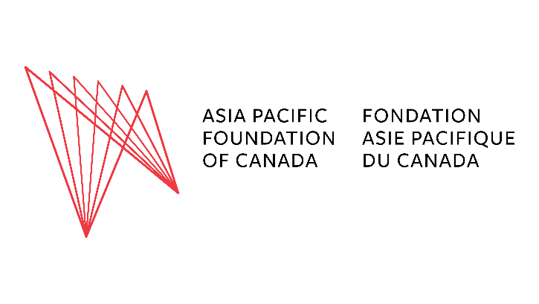
Canada-Asia Joint Research Grants
Call for Proposals (2025-2026)
Deadline: September 30, 2025, 11:59 p.m. PST
The Asia Pacific Foundation of Canada (APF Canada) is an independent, non-partisan, not-for-profit organization dedicated to strengthening Canada’s ties with Asia. As part of our Indo-Pacific Initiative, supported by funding from the Government of Canada, we invite proposals for joint research projects between Canadian and Indo-Pacific-based institutions. The purpose of this initiative is to build a greater understanding of specific policy issues and/or policy contexts in the Indo-Pacific region and generate actionable, policy-relevant insights on Canada’s engagement with the region.
Priority Themes
The thematic areas for this year’s call for applications include: space, energy security, regional security, supply chain resilience, critical minerals, and emerging technologies (including digital governance and artificial intelligence).
Eligibility
- Proposals must be jointly developed by at least one Canada-based institution and at least one institution based in the Indo-Pacific.
- The Canadian partner must serve as the lead applicant and grant holder.
Grant Details
- Amount: Up to C$50,000 per project
- Period: Funds must be expended by March 31, 2026
- Disbursement: Grant awarded to the Canadian lead, who may sub-grant to Indo-Pacific partners as needed
- Reporting: A two-page summary report due April 30, 2026

Eligible Costs
- Travel directly related to the joint research (fieldwork, partner meetings, conferences that materially advance the project). (Please see note below regarding restrictions on funding use.)
- Research or project assistants
- Local interpretation/translation services
- Activities with a partisan focus are not eligible for funding under the grant
Note on eligible expenses: Airfare costs should not exceed the lowest-fare economy class with the most direct route. The cost of meals and accommodation must be in accordance with the Canadian federal government’s travel directive. Ineligible costs include (but are not limited to) alcohol, gifts, bonuses, and gratuities.
Proposal Requirements (max. 5 pages)
Please address the following (use clear headings):
- Policy Focus & Relevance: What specific policy area will you address, and why does it matter for Canada? (e.g. alignment with one or more objectives of Canada’s Indo-Pacific Strategy).
- Partnership & Roles: Who are the Canadian and Indo-Pacific partners, and what will each contribute?
- Approach & Activities: What methods and activities will you undertake, and how will these produce policy-relevant insights?
- Outputs & Mobilization: What you will produce (e.g. policy briefs, reports, datasets, roundtables) and how you will reach decision-makers.
Annexes (not counted toward the 5-page limit):
- Workplan & timeline (with milestones)
- Detailed budget (with brief justifications)
Assessment Criteria
- Policy relevance & impact for Canadian stakeholders
- Quality and feasibility of the research design and workplan
- Strength and complementarity of the Canada–Indo-Pacific partnership
- Clarity of outputs and knowledge-mobilization plan
Key Dates
- Application deadline: September 30, 2025
- Decision notifications: October 15, 2025
- Project completion: March 31, 2026
- Summary report due: April 30, 2026
To submit your application and for inquiries, contact Ms. Yuko Uchida at yuko.uchida@asiapacific.ca.

