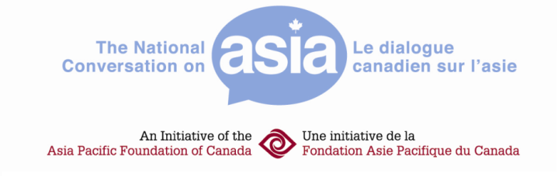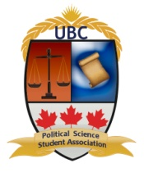
Registration Form for Campus Conversations on Asia
March 3 2012, 9:30 am – 3:30 pm at the Segal Building, SFU Downtown Campus
500 Granville Street, Vancouver, BC

Name | First Name | Last Name
Email Address

University or College
Major

Please sign up for ONE policy team (for descriptions, see next page).
□North Korea Task Force
□Independent Advisory Council on Burma
□Canada Corruption Watch Editorial Board
Will you be 19 years or older by March 3, 2012?
□Yes
□No
Please note any dietary restrictions (vegetarian, vegan, allergies, other)?

(Optional) What courses have you taken, or what background do you have in Asia?

(Optional) What interests you most about Asia?

Please send your completed form to Eventreservations@asiapacific.ca.
Policy Team Descriptions
In the afternoon session, you will work as part of a 6-8 member policy team that will produce a recommendation, assessment, or editorial decision based on one of three scenarios. Each scenario, which blends elements of fiction and reality, presents your group with a dilemma about which principles or values should take precedence over others and what types of trade-offs are acceptable. These scenarios are previewed below.
Policy Team 1: North Korea Task Force:
The Jeffrey Kim Foundation (JKF), one of the world’s wealthiest and most powerful philanthropies, has asked your group to decide whether to authorize $45 million in humanitarian assistance to alleviate North Korea’s severe food shortages. The UN has appealed to the JKF for help, noting that most foreign governments have canceled their food and medical aid. Most of these governments have cited their irritation over North Korea’s “nuclear antics” and its refusal to reform its economy. But the day before your team is scheduled to make its final recommendation, two unverified reports surface. The first calls into question the accuracy of the UN’s needs assessment. The second provides photographic evidence of the latest example of the Pyongyang’s bizarre behaviour. This new information forces the task force to hold an emergency session to review its recommendation.
Policy Team 2: Independent Advisory Council on Burma:
A group of retired diplomats has asked your team to review Canada’s policy of imposing “the toughest sanctions in the world” against Burma. These sanctions resulted from the Burmese government’s 2007 violent crackdown on civilians, including Buddhist monks. But this policy has come under scrutiny since 2011, when the Burmese government initiated a series of somewhat surprising political reforms. Ottawa has indicated that it may lift sanctions, but only if Burma’s April 2012 parliamentary elections produce “clear and incontrovertible signs” of democratization. The Advisory Council will hold a press conference to announce its assessment, but first must review a set of eyewitness accounts from international election monitors who paint a mixed and somewhat conflicting picture of just how democratic the elections were.
Policy Team 3: Canada Corruption Watch Editorial Board:
You sit on the editorial board of Canada Corruption Watch (CCW), a news organization devoted to serving the Canadian and international public interest. You have uncovered evidence that MacFadden Construction, a Canadian company known for its “exemplary” environmental standards, has bribed a minister in the Bangladesh government in order to win a $30 million road-building contract. If CCW publishes the bribery allegations, local media, activist groups and opposition politicians will demand that the Bangladesh government cancel the contract and publicly denounce MacFadden’s actions. But two Bangladeshi NGOs have requested a private, off-the-record meeting with your group to discuss the “unintended consequences” that could result if the story goes to press. Your editorial board must meet to decide which course of action best serves the public interest.

